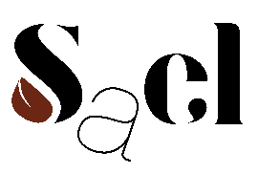

Prix Fixe Menu

Monday to Friday

12pm – 2:30pm, 5pm to 6.30pm

New Forest mushrooms, Cep jam, Cornish kern

OR

Ember-baked beetroot, fig leaf oil

‘Cod and Parsley Sauce'

OR

100-layer Hereford Ox Cheek lasagne

Burnt English cream, English apple vinegar

OR

Milk soft serve, Autumn berry Coulis